Atomic plans returned to Japan
http://news.bbc.co.uk/2/hi/asia-pacific/2170881.stm

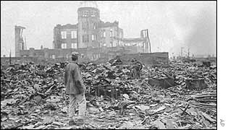
Japan is the only country to suffer a nuclear attack
Documents hidden since World War II showing Japan's plans for an atomic bomb have been returned to the country, according to a newspaper report.
The widow of the Japanese scientist who had spirited the documents out of the country after the war has given them to a Tokyo research institute, the Asahi daily says.
The 23-page dossier shows the Japanese army's plans for a relatively weak atomic bomb - blueprints that were ordered destroyed just before Japan's surrender in 1945.
The documents were instead secretly given to chemist Kazuo Kuroda, who then left for the United States and died there last year.
The documents, the newspaper says, could be a valuable addition to the study of Japan's wartime history.
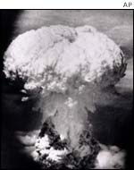
Japan surrendered six days after Nagasaki
They show how far Japan got in trying to build nuclear weapons of its own before the United States dropped atomic bombs on Hiroshima and Nagasaki, killing hundreds of thousands of people in August 1945 and forcing a surrender.
Weaker weapon
Kuroda, who was a professor emeritus at the University of Arkansas before his death in 2001, kept the documents secret for more than half a century.
His widow has sent the documents to the Riken scientific research institute just north of Tokyo where Kuroda worked as a young man, the Asahi newspaper reported.
A photograph published in the newspaper shows diagrams and drawings of a bomb, together with text written by a military officer who interviewed the scientist at the head of the atomic bomb development team.
But the newspaper says experts who have examined the documents do not believe the bomb would have been very powerful.

